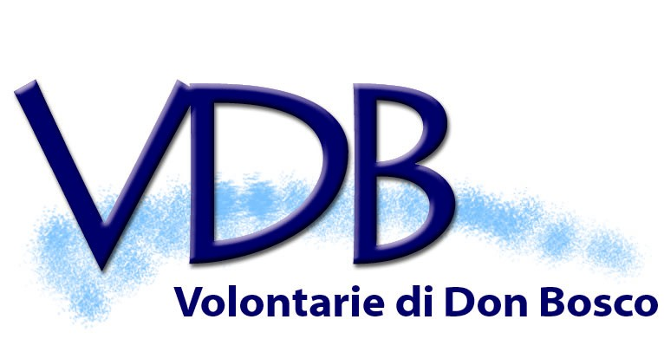

SECULAR INSTITUTE OF THE VOLUNTEERS OF DON BOSCO

Address to SDB Chapter members
In the name of the Salesian Family

My very dear Rector Major, Fr Pascual Chávez Villanueva,
Dear confreres taking part in GC27,
Esteemed guests, representatives of Salesian Family Groups.

I am truly happy to be able to share with you such an important moment for the Salesian Congregation and the entire Salesian Family of Don Bosco.

Every General Chapter is a privileged occasion for renewal and growth in fidelity to one’s charism; it certainly and especially is the case for the Chapter you are about to begin, given that the theme you have chosen goes right to the heart of the vocation to consecration: “Witnesses to the radical approach of the Gospel”.

Renewing personal and community encounter with Jesus, allowing oneself to be encountered by Him, allowing oneself to be renewed by Him, allowing Him to be at the heart of and the engine driving the community, is the way that helps shape consecrated hearts to being faithful witnesses. By seeking God and immersing ourselves in a strong spiritual experience we allow ourselves to take up the way of being and acting of the poor, chaste and obedient Jesus.

Today we experience a really tough situation which sees the world of the young needing to tackle an uncertain future, so many families threatened by destructive ideologies, politics and economy which have lost their human focus, institutions unable at times to respond to the needs of individuals. All of this obliges us, as true children of Don Bosco, to have the heart to suffer with, the eyes to see with, the mind to create, the courage to risk and go out, when needed, even against the flow. The way to holiness of our Salesian charism, guided by the “Da mihi animas caetera tolle”, is a precious pearl which Don Bosco guarded in the treasure chest of his life, woven in with “work and temperance”, and can help us to reawaken the world, re-animate consciences deadened by the culture of wellbeing, give mankind back its dignity, lead all to Jesus, Saviour and Redeemer.

The renewal that the Holy Spirit will achieve through this 27th General Chapter will be an encouragement and blessing for the Congregation and the entire Salesian Family, since we are like communicating vessels in a family: if fidelity, pastoral charity, authenticity, unity grow in one, all other groups benefit from it.

Allow me to once again briefly highlight certain aspects of our “journeying together”. Above all, I believe I can say that over these past twelve years we have benefited from having Fr Pascual Chávez as Rector Major, we have seen the Salesian Family walking together in a most fruitful way. There has been a growth in awareness that we are a great “charismatic and spiritual community”, committed making an original educative and apostolic contribution to the Church and the world (cf. Charter of Identity, art. 7); “exchanges between the Groups have been exploited, arriving at an ever more fraternal communion and a sharing which is ever more convinced of both the formation project and the missionary activity”, as in fact article 2 of the Charter of Identity of the Salesian Family states.

The activity of the World Consultative Body has become every more concrete and effective. Common opportunities for formation too, such as the Spirituality Days, have seen enthusiastic response, to the point where it has been difficult to contain the numbers wanting to take part.

Special thanks for all this must go to our dear Fr Chávez, Don Bosco alive amongst us, who so sensitively and enthusiastically has helped us to grow and to walk together on this path, and who has encouraged us by being part of the Chapters and general Assemblies of the various Groups and has always urged us to create unity and present ourselves to the young as a single great family in communion.

In the name of the various Salesian Family Groups I would like to express my thanks to all of you, our Salesian brothers throughout the world. Thank you especially for your fidelity, for your spirit of sacrifice and service. If it is true that every group in the Salesian family has its own autonomy, it is likewise true that thanks to your support, the spiritual nourishment you offer us so fraternally, so many of our groups and communities of consecrated and lay people have also succeeded in living in very difficult situations. I am thinking at the moment of the vocations that have arisen in young continents (for us) like Africa, Asia… where your help is fundamental.

I would like to offer particular thanks in the name of the Volunteers of Don Bosco and the Volunteers With Don Bosco, to the provincials and the many assistants of our groups across all the continents: thanks to you and to your belief in our vocation, so many of our circumstances have flourished around the world. You are instruments of the Holy Spirit who arouse in the Salesian Family an original way of living out lay, consecrated, Salesian life at the heart of the world.

From the time of Fr Rinaldi until now you have been an important and fundamental guide for theological reflection, charismatic research and for the understanding of our specific place in the Church. Your Salesian passion and conviction has helped us to be, as Paul VI defined it, “the Church’s advanced wing…, an experimental laboratory in which the Church can evaluate concrete ways of relating to the world”.

It is my wish that these days of the Chapter be an encouragement for the Congregation and the entire Salesian Family to embark on a new charismatic springtime and that our life may become ever more authentic, credible and fruitful.
Buon lavoro!

Olga Krizova
Moderator General
Secular Institute of the Volunteers of Don Bosco

